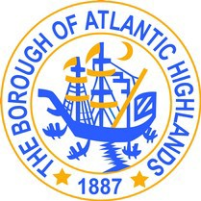
NOTICE OF MEETING

The Rent Leveling Board of the Borough of Atlantic Highlands will have a Meeting, at the Atlantic Highlands Borough Hall, 100 First Avenue, Atlantic Highlands, NJ at 7:00 pm on Thursday, August 21, 2025. The purpose of this meeting is to hear motions in regard to a tenant complaint. Formal action may be taken.

Michelle Clark
Municipal Clerk

