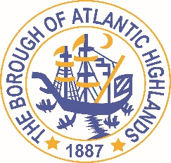
BOROUGH OF ATLANTIC HIGHLANDS
COUNTY OF MONMOUTH

RESOLUTION 009-2022

Authorizing Professional Services THROUGH A NON-FAIR AND OPEN Contract with Heyer, Gruel and associates for the CONTINUED MONITORING OF THE BOROUGHS HOUSING ELEMENT AND FAIR SHARE PLAN

WHEREAS, the Borough requires a professional planner for the preparation of a Housing Elements and Fair Share Plan that addresses the community's needs for affordable housing, while addressing COAH's requirements; and,

WHEREAS, Heyer, Gruel and Associates, a licensed planner in the State of New Jersey, is a recognized expert in the field of land use planning, and has represented Municipal Governments, Planning Boards and Zoning Boards for over twenty years has extensive experience in affordable housing and housing related issues, having prepared over 40 Housing Elements and Fair Share Plans.

WHEREAS, Heyer, Gruel and Associates, has completed and submitted:
- Business Entity Disclosure Certification, form required pursuant to N.J.S.A. 19:44A-20.8, which certifies that Heyer, Gruel and Associates has not made any reportable contributions to a political or candidate committee in the Borough of Atlantic Highlands in the previous one year, and that the contract will prohibit Heyer Gruel and Associates from making any reportable contributions through the term of the contract,
- Political Contribution Disclosure form required pursuant to N.J.S.A. 19:44A-1 et seq.
- Stockholder Disclosure Certification form required pursuant to N.J.S.A. 19:44A-20.8
- Iran Statement
- Certification of Compliance form required pursuant to Section 9-2.5 of the Revised General Ordinances of the Borough of Atlantic Highlands
- Valid New Jersey Business Registration Certificate pursuant to P.L. 2004, c.57

WHEREAS, Holman Frenia Allison, PC (HFA), Chief Financial Officer for the Borough of Atlantic Highlands, has certified that funds are available for this contract.

NOW, THEREFORE, BE IT RESOLVED, by the Governing Body of the Borough of Atlantic Highlands, County of Monmouth, State of New Jersey, the Mayor, Business Administrator and other necessary officials of the Borough of Atlantic Highlands are hereby authorized to execute an agreement, in an amount not to exceed $10,000, with Heyer, Gruel and Associates for the continued monitoring of the Borough’s Housing Element and Fair Share Plan and other duties as assigned; and,

BE IT FURTHER RESOLVED that notice of this action shall be printed once in an official newspaper of the Borough and that this Resolution and the contract shall be available for public inspection in the Office of the Municipal Clerk.

Motion: Approve Resolution 009-2022 Moved by Councilman Boms; Seconded by Councilman Boracchia
Vote: Motion carried by roll call vote (summary: Yes = 6).

Yes: Councilman Boms, Councilman Boracchia, Councilman Crowley, Councilman Dougherty, Councilwoman Hohenleitner, Councilman Murphy
No: None
Abstain: None
Absent: None

I, Michelle Clark, Municipal Clerk of the Borough of Atlantic Highlands, in the County of Monmouth, State of New Jersey, hereby certify this to be a true copy of the action of the Governing Body, at its Reorganization Meeting held January 1, 2022. WITNESS my hand this 3rd day of January 2022.
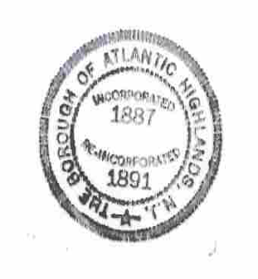
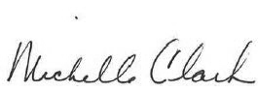
Michelle Clark, Municipal Clerk

