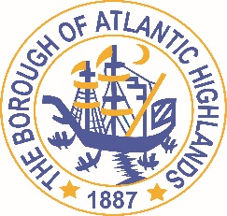
BOROUGH OF ATLANTIC HIGHLANDS
COUNTY OF MONMOUTH

RESOLUTION 179-2020

RESOLUTION AUTHORIZING THE AWARD OF
A NON-FAIR AND OPEN CONTRACT FOR
THE INSPECTION OF HELIX

WHEREAS, the Borough of Atlantic Highlands has a need to acquire the services of a diver for the purpose of helix inspections as a non-fair and open contract pursuant to the provisions of N.J.S.A. 19:44A-20.4; and,

WHEREAS, the qualified purchasing agent has determined that the value of the need will exceed $17,500; and,

WHEREAS, the anticipated term of this contract is 1year; and

WHEREAS, Hurricane Marine LLC and Miller Towing and Salvage have both submitted proposals indicating they will provide the inspection services including all reports as required by the Harbor Manager; and

WHEREAS Hurricane Marine LLC was the lowest responsible / responsive to the Request for Proposals at a cost of $ 25,900.00; and

WHEREAS, Hurricane Marine has completed and submitted a Business Entity Disclosure Certification which certifies that Hurricane Marine has not made any reportable contributions to a political or candidate committee in the Borough Council in the previous one year, and that the contract will prohibit the Hurricane Marine from making any reportable contributions through the term of the contract; and

WHEREAS, the Borough of Atlantic Highlands Chief Financial Officer has certified the availability of funds from account 30-201-20-101-259.

NOW THEREFORE, BE IT RESOLVED that the Mayor and Council of the Borough of Atlantic Highlands authorizes the Harbor Manager to enter into a contract with Hurricane Marine as described herein; and,

BE IT FURTHER RESOLVED that the Business Disclosure Entity Certification and the Determination of Value be placed on file with this resolution.

BE IT FURTHER RESOLVED that a notice of this action shall be printed once in an official newspaper of the Borough and that this Resolution and the contract shall be available for public inspection in the office of the Municipal Clerk

Motion: Approve Resolution Moved by Councilman Dellosso, Seconded by Councilman Crowley
Vote: Motion carried by unanimous roll call vote (summary: Yes = 6).

Yes: Councilman Boms, Councilman Boracchia, Councilman Crowley, Councilman Dellosso, Councilwoman Hohenleitner, Councilman Murphy
No: None
Absent: None

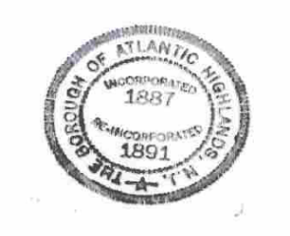
I, Michelle Clark, Municipal Clerk of the Borough of Atlantic Highlands, in the County of Monmouth, State of New Jersey, hereby certify this to be a true copy of the action of the Governing Body, at its Regular Meeting, held October 8, 2020, WITNESS my hand this 9th day of October 2020.
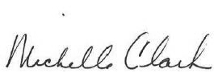
Michelle Clark, Municipal Clerk

