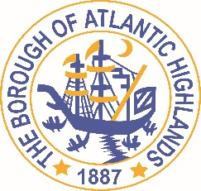
BOROUGH OF ATLANTIC HIGHLANDS
COUNTY OF MONMOUTH

RESOLUTION 122-2020
RESOLUTION AUTHORIZING THE AWARD OF A
NON-FAIR AND OPEN CONTRACT FOR SOFTWARE / TECHNOLOGICAL SERVICES TO SECURUS TECHNOLOGIES INC / ARCHONIX

WHEREAS, the Borough of Atlantic Highlands Police Department has a need to continue the use of Archonix CAD/XRMS Licensed Software and Maintenance which has been used in the department for over 10 years as a non-fair and open contract pursuant to the provisions of N.J.S.A. 19:44A-20.4 or 20.5; and,

WHEREAS, the Purchasing Agent has determined and certified in writing that the value of the acquisition will not exceed $17,500 but is over the 2-quote requirement of $6,600; and,

WHEREAS, the anticipated term of this contract is 1 year and may be extended 1time as approved by this governing body; and

WHEREAS, Securus Technologies Inc / Archonix has submitted a proposal indicating they will provide the Software / technological services for $12,896; and

WHEREAS, Securus Technologies Inc has completed and submitted a Business Entity Disclosure Certification which certifies that Securus Technologies Inc., has not made any reportable contributions to a political or candidate committee in the Borough of Atlantic Highlands in the previous one year, and that the contract will prohibit the Securus Technologies Inc. from making any reportable contributions through the term of the contract, and

WHEREAS, the Borough of Atlantic Highlands C.F.O. has certified funds are available to charge account #0120125240206

NOW THEREFORE, BE IT RESOLVED that the Mayor and Council of the Borough Atlantic Highlands authorizes the Borough Administrator to enter into a contract with Securus Technologies Inc as described herein; and,

BE IT FURTHER RESOLVED that the Business Disclosure Entity Certification and the Determination of Value be placed on file with this resolution. and

BE IT FURTHER RESOLVED that a notice of this action shall be printed once in an official newspaper of the Borough and that this Resolution and the contract shall be available for public inspection in the office of the Municipal Clerk

Motion: Approve Resolution Moved by Councilwoman Hohenleitner; Seconded by Councilman Boms
Vote: Motion carried by unanimous roll call vote (summary: Yes = 6).

Yes: Councilman Boms, Councilman Boracchia, Councilman Crowley, Councilman Dellosso, Councilwoman Hohenleitner, Councilman Murphy
No: None
Absent: None

I, Michelle Clark, Municipal Clerk of the Borough of Atlantic Highlands, in the County of Monmouth, State of New Jersey, hereby certify this to be a true copy of the action of the Governing Body, at its Regular Meeting, held June 11, 2020. WITNESS my hand this 12th day of June 2020.
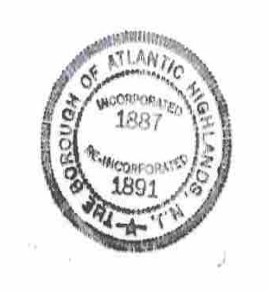
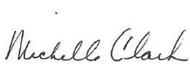
Michelle Clark, Municipal Clerk

