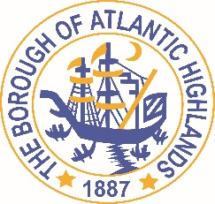
BOROUGH OF ATLANTIC HIGHLANDS
COUNTY OF MONMOUTH

RESOLUTION 145-2017

RESOLUTION AUTHORIZING THE AWARD OF A
NON-FAIR AND OPEN CONTRACT FOR INSTALLATION OF FILL BOXES AND FUEL TANKS AT THE MARINA

WHEREAS, the Borough of Atlantic Highlands has a need to acquire a contractor for goods and services as a non-fair and open contract pursuant to the provisions of N.J.S.A. 19:44A-20.4 and,

WHEREAS, the Purchasing Agent has determined and certified in writing that the value of the acquisition will exceed $17,500; and,

WHEREAS, the anticipated term of this contract is 1 year; and

WHEREAS, Independence Constructors has submitted a proposal indicating they will provide the such goods and services for $24,289.; and

WHEREAS, Independence Constructors has completed and submitted a Business Entity Disclosure Certification which certifies that Independence Constructors has not made any reportable contributions to a political or candidate committee in the Borough of Atlantic Highlands in the previous one year, and that the contract will prohibit the Independence Constructors from making any reportable contributions through the term of the contract, and

WHEREAS, the Borough of Atlantic Highlands C.F.O. has certified funds to charge account #30-201-44-950-301 for $20,000.00 and account #30-201-20-104-295 for $4,289.00 ; and

NOW THEREFORE, BE IT RESOLVED that the Mayor and Council of the Borough Atlantic Highlands authorizes the Borough Administrator to enter into a contract with Independence Constructors, 1200 Route 22 East, Bridgewater, New Jersey as described herein; and,

BE IT FURTHER RESOLVED that the Business Disclosure Entity Certification and the Determination of Value be placed on file with this resolution. and,

Motion: Approve Resolution, Moved by Councilman Dellosso; Seconded by Councilman Boracchia
Vote: Motion carried by roll call vote (summary: Yes = 5).
Yes: Councilman Boracchia, Councilman Dellosso, Councilman Doyle, Councilman Fligor, Councilman Lero
Absent: Councilman Archibald

I, Michelle Clark, Acting Municipal Clerk of the Borough of Atlantic Highlands, in the County of Monmouth, State of New Jersey, hereby certify this to be a true copy of the action of the Governing Body, at its Regular Meeting, held November 8, 2017. WITNESS my hand this 9th day of November 2017.
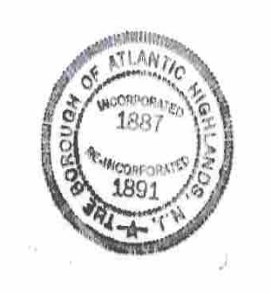
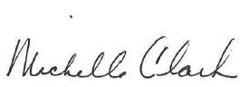
Michelle Clark
Acting Municipal Clerk

