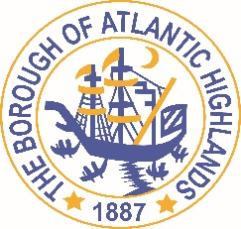
BOROUGH OF ATLANTIC HIGHLANDS
COUNTY OF MONMOUTH

RESOLUTION 140-2017

RESOLUTION AUTHORIZING THE AWARD OF A
NON-FAIR AND OPEN CONTRACT FOR SENIOR BUILDING MEN’S PUBLIC RESTROOM

WHEREAS, the Borough of Atlantic Highlands has a need to acquire a contractor for goods and services as a non-fair and open contract pursuant to the provisions of N.J.S.A. 19:44A-20.4 or 20.5; and,

WHEREAS, the Purchasing Agent has determined and certified in writing that the value of the acquisition will exceed $17,500; and,

WHEREAS, the anticipated term of this contract is 1 year; and

WHEREAS, FMS Construction has submitted a proposal indicating they will provide the such goods and services for the $29,995.; and

WHEREAS, The FMS Construction has completed and submitted a Business Entity Disclosure Certification which certifies that FMS Construction has not made any reportable contributions to a political or candidate committee in the Borough of Atlantic Highlands in the previous one year, and that the contract will prohibit the FMS Construction from making any reportable contributions through the term of the contract, and

WHEREAS, the Borough of Atlantic Highlands C.F.O. has certified funds to charge account #30-201-44-950-301; and

NOW THEREFORE, BE IT RESOLVED that the Mayor and Council of the Borough Atlantic Highlands authorizes the Borough Administrator to enter into a contract with FMS Construction as described herein; and,

BE IT FURTHER RESOLVED that the Business Disclosure Entity Certification and the Determination of Value be placed on file with this resolution, and that a notice of this action shall be printed once in an official newspaper of the Borough and that this Resolution and the contract shall be available for public inspection in the office of the Municipal Clerk
Motion: Approve Resolution, Moved by Councilman Dellosso; Seconded by Councilman Boracchia
Vote: Motion carried by roll call vote (summary: Yes = 5).
Yes: Councilman Boracchia, Councilman Dellosso, Councilman Doyle, Councilman Fligor, Councilman Lero
Absent: Councilman Archibald

I, Michelle Clark, Acting Municipal Clerk of the Borough of Atlantic Highlands, in the County of Monmouth, State of New Jersey, hereby certify this to be a true copy of the action of the Governing Body, at its Regular Meeting, held November 8, 2017. WITNESS my hand this 9th day of November 2017.
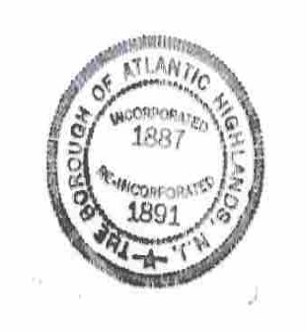
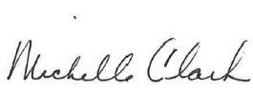
Michelle Clark
Acting Municipal Clerk

