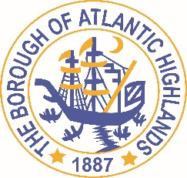
BOROUGH OF ATLANTIC HIGHLANDS
COUNTY OF MONMOUTH

RESOLUTION 103-2017

RESOLUTION AUTHORIZING THE AWARD OF A
NON-FAIR AND OPEN CONTRACT FOR ARCHITECTUAL SERVICES FOR THE MARINA TO THE GOLDSTEIN PARTNERSHIP

WHEREAS, the Borough of Atlantic Highlands has a need to acquire architectural services as a non-fair and open contract pursuant to the provisions of N.J.S.A. 19:44A-20.4 or 20.5; and,

WHEREAS, the Purchasing Agent has determined and certified in writing that the value of the acquisition will exceed $17,500; and,

WHEREAS, the anticipated term of this contract is 2 years and may be extended 1time as approved by this governing body; and

WHEREAS, The Goldstein Partnership has submitted a proposal indicating they will provide the architectural services for $49,880 with $11,100 already encumbered and paid leaving a contract amount open for $38,780; and

WHEREAS, The Goldstein Partnership has completed and submitted a Business Entity Disclosure Certification which certifies that The Goldstein Partnership has not made any reportable contributions to a political or candidate committee in the Borough of Atlantic Highlands in the previous one year, and that the contract will prohibit the The Goldstein Partnership from making any reportable contributions through the term of the contract, and

WHEREAS, the Borough of Atlantic Highlands C.F.O. has certified funds to charge account #31-215-55-561-106; and

NOW THEREFORE, BE IT RESOLVED that the Mayor and Council of the Borough Atlantic Highlands authorizes the Borough Administrator to enter into a contract with The Goldstein Partnership as described herein; and,

BE IT FURTHER RESOLVED that the Business Disclosure Entity Certification and the Determination of Value be placed on file with this resolution. and,

BE IT FURTHER RESOLVED that a notice of this action shall be printed once in an official newspaper of the Borough and that this Resolution and the contract shall be available for public inspection in the office of the Municipal Clerk.

Motion: Approve Resolution, Moved by Councilman Dellosso; Seconded by Councilman Fligor.
Vote: Motion carried by roll call vote (summary: Yes = 6).
Yes: Councilman Archibald, Councilman Boracchia, Councilman Dellosso, Councilman Doyle, Councilman Fligor, Councilman Lero

I, Michelle Clark, Acting Municipal Clerk of the Borough of Atlantic Highlands, in the County of Monmouth, State of New Jersey, hereby certify this to be a true copy of the action of the Governing Body, at its Regular Meeting, held July 26, 2017. WITNESS my hand this 27 day of July 2017.
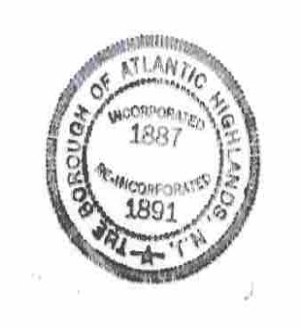
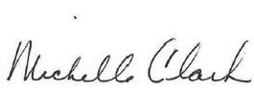

Michelle Clark
Acting Municipal Clerk

