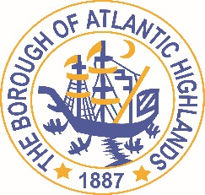
BOROUGH OF ATLANTIC HIGHLANDS
COUNTY OF MONMOUTH

RESOLUTION 098-2017

RESOLUTION AUTHORIZING THE AWARD OF

A NON-FAIR AND OPEN CONTRACT FOR

THE INSTALLATION OF A FIRE HYDRANT

WHEREAS, the Atlantic Highland Water Department has decided to award a contract for the installation of a fire hydrant as a non-fair and open contract pursuant to the provisions of N.J.S.A. 19:44A-20.5; and,
WHEREAS, the QPA has determined that the aggregate value of this contract along with previously issued related contracts will exceed $17,500; and,

WHEREAS, the anticipated term of this contract is less than 1 year; and,

WHEREAS, Mark Woszczak Mechanical. has submitted a proposal indicating they will install a 4” line stop, 4” insertion valve, and provide the replacement hydrant for the Installation for $20,300.00; and,

WHEREAS, Mark Woszczak Mechanical has completed and submitted a Business Entity Disclosure Certification which certifies that Mark Woszczak Mechanical has not made any reportable contributions to a political or candidate committee in the Borough of Atlantic Highlands in the previous one year, and that the contract will prohibit Mark Woszczak Mechanical from making any reportable contributions through the term of the contract; and,

WHEREAS, Gerard Gagliano, Chief Financial Officer for the Borough of Atlantic Highlands, has certified that funds are available for this purpose;

NOW, THEREFORE, BE IT RESOLVED, by the Governing Body of the Borough of Atlantic Highlands, County of Monmouth, State of New Jersey, that the Borough Administrator and the Atlantic Highlands Water Department are authorized and directed to enter an agreement with Mark Woszczak Mechanical for the installation of a fire hydrant, in an amount not to exceed $20,300.00

Be it further RESOLVED that a notice of this action shall be printed once in an official newspaper of the Borough and that this Resolution and the contract shall be available for public inspection in the office of the Municipal Clerk.

Motion: Approve Resolution, Moved by Councilman Doyle; Seconded by Councilman Fligor.
Vote: Motion carried by roll call vote (summary: Yes = 5).
Yes: Councilman Archibald, Councilman Doyle, Councilman Fligor, Councilman Boracchia, Councilman Lero.

I, Michelle Clark, Acting Municipal Clerk of the Borough of Atlantic Highlands, in the County of Monmouth, State of New Jersey, hereby certify this to be a true copy of the action of the Governing Body, at its Regular Meeting, held July 12, 2017. WITNESS my hand this 13 day of July 2017.
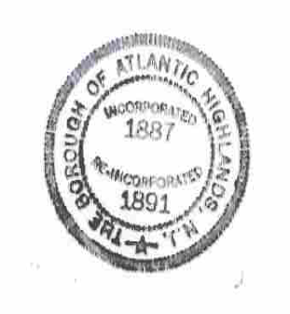
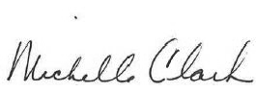

Michelle Clark
Acting Municipal Clerk

