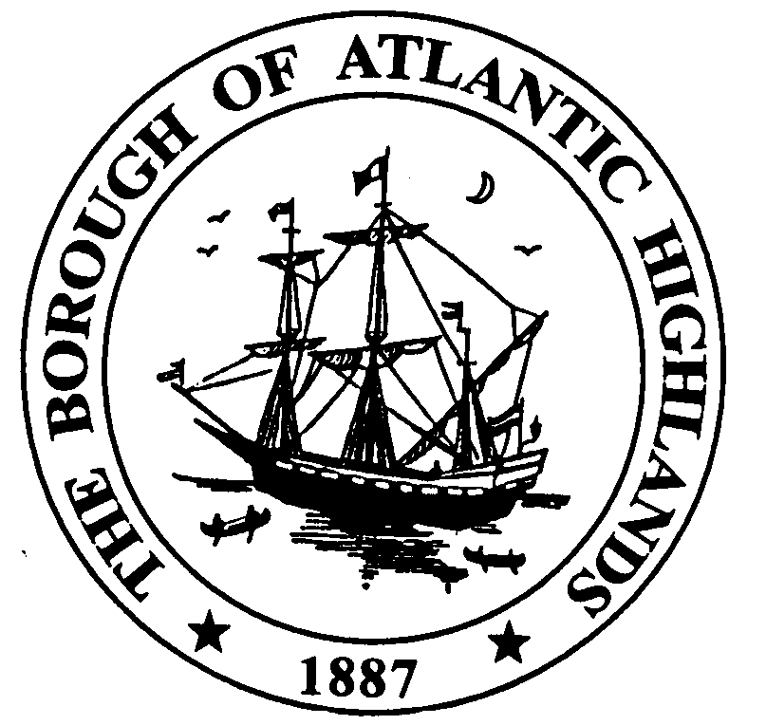
NOTICE OF HEARING

PLEASE TAKE NOTICE that the Governing Body of the Borough of Atlantic Highlands introduced Ordinance 06-2011, at their Regular Meeting held on March 23, 2011. This Ordinance is scheduled to have a Second Reading and Public Hearing on April 13, 2011 at 7:00 PM at Borough Hall, 100 First Avenue, Atlantic Highlands, NJ, in the Public Meeting Room. Anyone interested shall be given the opportunity to be heard concerning this ordinance. Immediately following the Public Hearing, final Adoption will be considered. This Ordinance is available for public inspection at Borough Hall in the Municipal Clerk’s office during regular business hours, 8:30 AM to 4:30 PM, Monday through Friday.

Dwayne M. Harris
Municipal Clerk

Ordinance 06-2011

CALENDAR YEAR 2011
ORDINANCE TO EXCEED THE MUNICIPAL BUDGET APPROPRIATION LIMITS

AND TO ESTABLISH A CAP BANK
(N.J.S.A. 40A: 4-45.14)

WHEREAS, the Local Government Cap Law, N.J.S. 40A: 4-45.1 et seq., provides that in the preparation of its annual budget, a municipality shall limit any increase in said budget to 2.0% unless authorized by ordinance to increase it to 3.5% over the previous year’s final appropriations, subject to certain exceptions; and,
WHEREAS, N.J.S.A. 40A: 4-45.15a provides that a municipality may, when authorized by ordinance, appropriate the difference between the amount of its actual final appropriation and the 3.5% percentage rate as an exception to its final appropriations in either of the next two succeeding years; and,
WHEREAS, the Borough Council of the Borough of Atlantic Highlands in the County of Monmouth finds it advisable and necessary to increase its CY 2011 budget by up to 3.5% over the previous year’s final appropriations, in the interest of promoting the health, safety and welfare of the citizens; and,
WHEREAS, the Borough Council hereby determines that a 3.5 % increase in the budget for said year, amounting to $77,740.44 in excess of the increase in final appropriations otherwise permitted by the Local Government Cap Law, is advisable and necessary; and,
WHEREAS, the Borough Council hereby determines that any amount authorized hereinabove that is not appropriated, as part of the final budget shall be retained as an exception, to final appropriation in either of the next two succeeding years;
NOW THEREFORE BE IT ORDAINED, by the Borough Council of the Borough of Atlantic Highlands, in the County of Monmouth, a majority of the full authorized membership of this governing body affirmatively concurring, that, in the CY 2011 budget year, the final appropriations of the Borough of Atlantic Highlands shall, in accordance with this ordinance and N.J.S.A. 40A: 4-45.14, be increased by 3.5 %, amounting to $181,394.36 and that the CY 2011 municipal budget for the Borough of Atlantic Highlands be approved and adopted in accordance with this ordinance; and,
BE IT FURTHER ORDAINED, that any that any amount authorized hereinabove that is not appropriated as part of the final budget shall be retained as an exception to final appropriation in either of the next two succeeding years; and,
BE IT FURTHER ORDAINED, that a certified copy of this ordinance as introduced be filed with the Director of the Division of Local Government Services within 5 days of introduction; and,
BE IT FURTHER ORDAINED, that a certified copy of this ordinance upon adoption, with the recorded vote included thereon, is filed with said Director within 5 days after such adoption.

