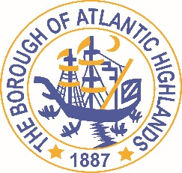
BOROUGH OF ATLANTIC HIGHLANDS
COUNTY OF MONMOUTH

RESOLUTION 152-2022

Authorizing Non-Fair and Open Contract for Financial Advisor for Regionalization

WHEREAS, there exists a need to appoint a qualified Professional Consultant to provide independent financial advice pertaining to the regionalization of schools for the Borough of Atlantic Highlands; and

WHEREAS, while the Local Public Contracts Law (N.J.S.A. 40A:11-5 (1)(a) does not require competitive bidding for this position; and

WHEREAS, due consideration as to qualifications, experience, compensation and other factors and criteria were reviewed considering Robert Benecke F.A., CMFO, and Chelsea Gleis, P.P. of Benecke Economics; and

WHEREAS, the scope of the proposed work is to prepare a financial structure and impact analysis (report) on the proposed consolidation of the Highlands Elementary, Atlantic Highlands Elementary and the Henry Hudson Regional High School districts as well as the possible consolidation of Sea Bright schools. The consolidation of debt, operating expenses and the impact on the respective tax levies and tax rates will be examined as well as providing guidance on municipal, school budget and perhaps county tax impacts and school demographics—student impacts, prepare a statutory tax assessment distribution and fiscal plan and other financial work as necessary. The fees to be paid are $150 per hour, capped at 40 hours – not to exceed $6,000.

NOW THEREFORE, BE IT RESOLVED that the Borough Council of the Borough of Atlantic Highlands, County of Monmouth, State of New Jersey authorizes the Borough Administrator to execute a contract with Benecke Economics for the work proposed as stated above.

BE IT FURTHER RESOLVED that the Borough Clerk is hereby authorized to advertise this award of contract according to law in the local newspaper.

Motion: Approve Resolution Moved by Councilman Murphy; Seconded by Councilman Dougherty
Vote: Motion carried by roll call vote (summary: Yes = 6).
Yes: Councilman Murphy, Councilwoman Hohenleitner, Councilman Dougherty, Councilman Crowley, Councilman Boracchia, Councilman Boms
No: None
Absent: None

I, Michelle Clark, Municipal Clerk of the Borough of Atlantic Highlands, in the County of Monmouth, State of New Jersey, hereby certify this to be a true copy of the action of the Governing Body, at its Regular Meeting, held October 13, 2022, WITNESS my hand this 14th day of October 2022.
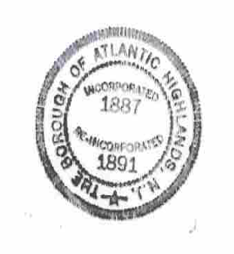
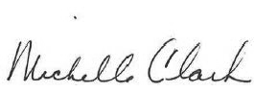
Michelle Clark, Municipal Clerk

