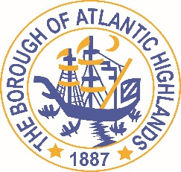
BOROUGH OF ATLANTIC HIGHLANDS
COUNTY OF MONMOUTH

RESOLUTION 011-2022

Authorizing award OF a NON-FAIR AND OPEN contract for professional services pursuant to N.J.S.A. 19:44 a–20.5

WHEREAS, the Borough of Atlantic Highlands needs to retain Michael B. Steib, Esq. to serve as Special Counsel to the Borough of Atlantic Highlands, as a non-fair and open contract pursuant to the provisions of NJSA.19: 44A-20.5 et al; and,

WHEREAS, the terms of this contract terminate on December 31, 2022; and,

WHEREAS, Michael B. Steib has completed and submitted:
- Business Entity Disclosure Certification which certifies that Michael B. Steib has not made any reportable contributions to a political or candidate committee in the Borough of Atlantic Highlands in the previous one year, and that the contract will prohibit Michael B. Steib from making any reportable contributions through the term of the contract,
- Political Contribution Disclosure form required pursuant to N.J.S.A. 19:44A-20.8
- Stockholder Disclosure Certification form required pursuant to N.J.S.A. 19:44A-20.8
- Iran Statement
- Certification of Compliance form required pursuant to Section 9-2.5 of the Revised General Ordinances of the Borough of Atlantic Highlands
- Valid New Jersey Business Registration Certificate pursuant to P.L. 2004, c.57

WHEREAS, Holman Frenia Allison, PC (HFA), Chief Financial Officer for the Borough of Atlantic Highlands, has certified that funds are or will be available for this contract.

NOW THEREFORE, BE IT RESOLVED that the Governing Body of the Borough of Atlantic Highlands authorizes the Mayor and Borough Administrator to enter into a contract with Michael B. Steib at the rates established in his contract for professional services; and,

BE IT FURTHER RESOLVED, a notice of this action shall be printed once in an official newspaper of the Borough and that this Resolution and the contract shall be available for public inspection in the office of the Municipal Clerk.

Motion: Approve Resolution 011-2022 Moved by Councilman Dougherty; Seconded by Councilwoman Hohenleitner
Vote: Motion carried by roll call vote (summary: Yes = 5, No = 1).

Yes: Councilman Boms, Councilman Boracchia, Councilman Dougherty, Councilwoman Hohenleitner, Councilman Murphy
No: Council Crowley
Abstain: None
Absent: None

I, Michelle Clark, Municipal Clerk of the Borough of Atlantic Highlands, in the County of Monmouth, State of New Jersey, hereby certify this to be a true copy of the action of the Governing Body, at its Reorganization Meeting held January 1, 2022. WITNESS my hand this 3rd day of January 2022.
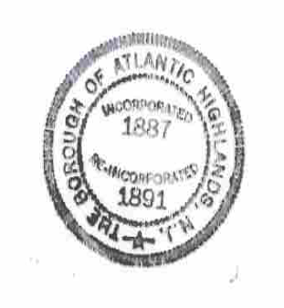
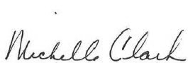
Michelle Clark, Municipal Clerk

