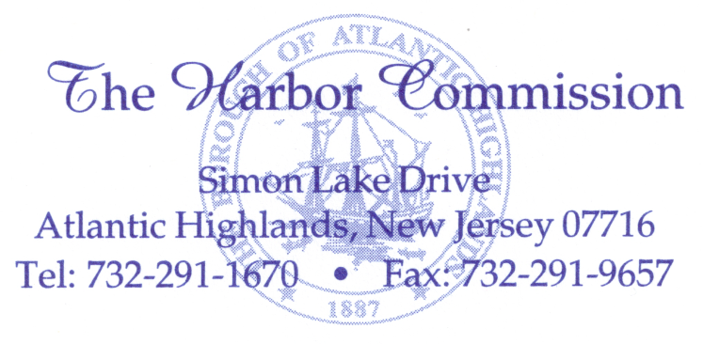

REGUALR MEETING – TUESDAY SEPTEMBER 10th, 2013 AT 7:00PM
BOROUGH HALL, 100 FIRST AVENUE, ATLANTIC HIGHLANDS N.J.
AGENDA

This Regular Meeting of the Atlantic Highlands Harbor Commission is called pursuant to the provisions of the Open Public Meetings Law. Adequate notice has been provided by transmitting the Resolution of Annual Meetings to the Asbury Park Press and The Two River Times and by posting it on the bulletin boards in the Harbor Office and Borough Hall reserved for such announcements and by filing it with the Municipal Clerk on January 9, 2013. This agenda is complete to the extent known and formal action will be taken.
Roll call
Pledge of allegiance
Moment of silence

CORRESPONDENCE: None

ADMINISTRATION:
Approve minutes of August 27^{th,} 2013 Harbor Commission Meeting
Approve minutes of the Harbor Commission Executive Session Meeting of August 27, 2013
Approval of Payment of Bills
Harbor Utility Income Report for August 2013
Status report from T&M Associates: Eric Nathanson

COMMITTEE REPORTS:
Clean Marina: Mrs. Marchetti, Mr. Curry
Finance & Personnel: Mr. Archibald, Chair Al Thompson
Operations: Mr. Hoffmann, Chair Al Thompson
Leases: Mr. Curry, Chair Al Thompson
Capital improvements & Special reports: Mr. McDonald, Chair Helen Marchetti

ADMINISTORS REPORT: Mr. Hubeny
ATTORNEY’S REPORT: Mr. Corodemus
HARBOR MANAGERS REPORT: Mr. White
OLD BUSINESS:
NEW BUSINESS:
PUBLIC PORTION:
EXECUTIVE SESSION: T&M Associates contract discussions.
ADJOURN

